Catalan Solids

Definition
# Source: AI Source: Provided by: [Data Path: Persons Table -> ID Column: 1, Name_En Column: Motasem Essam] -> From: [ChatGPT] on [7/25/2026]
Catalan solids are a family of 13 convex polyhedra in which every face is a congruent polygon, but the faces are generally not regular polygons.
They are the duals of the 13 Archimedean solids. This means that each Catalan solid is obtained by exchanging the vertices and faces of its corresponding Archimedean solid.
Catalan solids are also known as Archimedean duals.

Simple Definition
# Source: AI Source: Provided by: [Data Path: Persons Table -> ID Column: 1, Name_En Column: Motasem Essam] -> From: [ChatGPT] on [7/25/2026]
A Catalan solid is a convex three-dimensional shape made from identical polygonal faces, with the same type of face repeated throughout the solid.
Unlike Platonic solids, its faces are not necessarily regular polygons, and its vertices do not all have the same arrangement of faces.

Geometric Structure
# Source: AI Source: Provided by: [Data Path: Persons Table -> ID Column: 1, Name_En Column: Motasem Essam] -> From: [ChatGPT] on [7/25/2026]
- All faces are congruent polygons.
- The faces are generally irregular polygons.
- The solid is convex.
- Every edge belongs to exactly two faces.
- The vertices may have different configurations.
- Each Catalan solid is dual to an Archimedean solid.

The 13 Catalan Solids
# Source: AI Source: Provided by: [Data Path: Persons Table -> ID Column: 1, Name_En Column: Motasem Essam] -> From: [ChatGPT] on [7/25/2026]
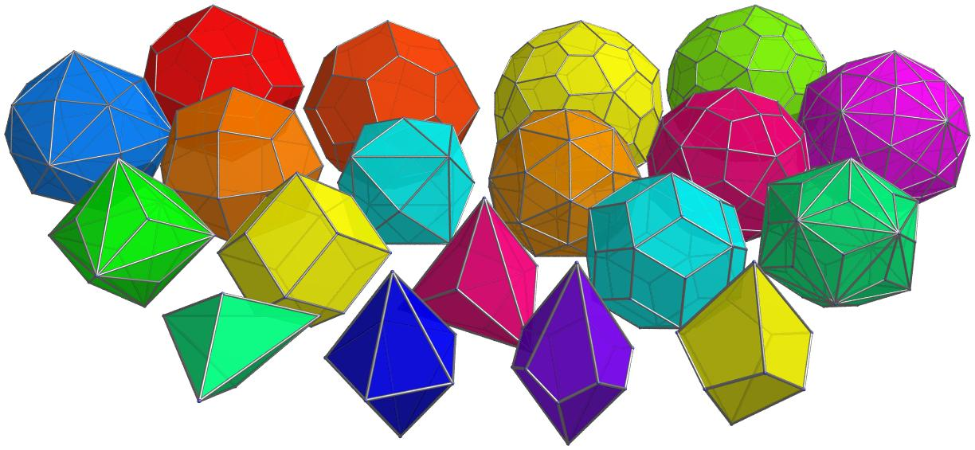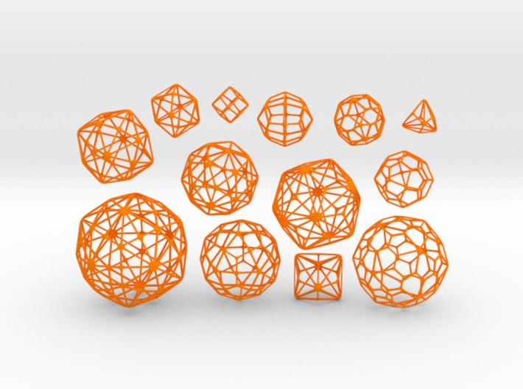
The 13 Catalan solids are:
- Triakis Tetrahedron
- Rhombic Dodecahedron
- Tetrakis Hexahedron
- Triakis Octahedron
- Deltoidal Icositetrahedron
- Disdyakis Dodecahedron
- Pentagonal Icositetrahedron
- Triakis Icosahedron
- Rhombic Triacontahedron
- Pentakis Dodecahedron
- Deltoidal Hexecontahedron
- Disdyakis Triacontahedron
- Pentagonal Hexecontahedron

Complete list and properties
# Source: AI Source: Provided by: [Data Path: Persons Table -> ID Column: 1, Name_En Column: Motasem Essam] -> From: [ChatGPT] on [7/25/2026]
Each Catalan solid has a corresponding Archimedean solid. The table gives the number of faces (F), edges (E), and vertices (V).
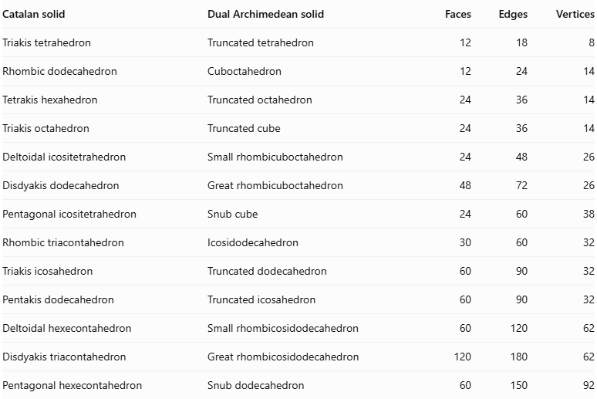
Catalan solid | Dual Archimedean solid | Faces | Edges | Vertices
Triakis tetrahedron | Truncated tetrahedron | 12 | 18 | 8
Rhombic dodecahedron | Cuboctahedron | 12 | 24 | 14
Tetrakis hexahedron | Truncated octahedron | 24 | 36 | 14
Triakis octahedron | Truncated cube | 24 | 36 | 14
Deltoidal icositetrahedron | Small rhombicuboctahedron | 24 | 48 | 26
Disdyakis dodecahedron | Great rhombicuboctahedron | 48 | 72 | 26
Pentagonal icositetrahedron | Snub cube | 24 | 60 | 38
Rhombic triacontahedron | Icosidodecahedron | 30 | 60 | 32
Triakis icosahedron | Truncated dodecahedron | 60 | 90 | 32
Pentakis dodecahedron | Truncated icosahedron | 60 | 90 | 32
Deltoidal hexecontahedron | Small rhombicosidodecahedron | 60 | 120 | 62
Disdyakis triacontahedron | Great rhombicosidodecahedron | 120 | 180 | 62
Pentagonal hexecontahedron | Snub dodecahedron | 60 | 150 | 92

Main characteristics
# Source: AI Source: Provided by: [Data Path: Persons Table -> ID Column: 1, Name_En Column: Motasem Essam] -> From: [ChatGPT] on [7/25/2026]
1. Face-transitive: Every face can be mapped onto any other face by a symmetry of the solid. This is why all faces are congruent.
2. Generally irregular faces: Their faces are congruent but are not generally regular polygons. For example, a deltoidal icositetrahedron has kite-shaped faces.
3. Different vertex arrangements: Not every vertex necessarily has the same number or arrangement of faces meeting there.
4. Convexity: All 13 Catalan solids are convex polyhedra.
5. Dual relationship: The faces of a Catalan solid correspond to the vertices of its Archimedean dual, and its vertices correspond to the faces of that dual.

Mathematical Properties

Euler's formula
# Source: AI Source: Provided by: [Data Path: Persons Table -> ID Column: 1, Name_En Column: Motasem Essam] -> From: [ChatGPT] on [7/25/2026]
Every Catalan solid satisfies Euler's polyhedron formula:
$$V-E+F=2$$
Where:
- $V$ = number of vertices
- $E$ = number of edges
- $F$ = number of faces
For example, the Deltoidal Icositetrahedron has:
$$26-48+24=2$$

Duality rules
# Source: AI Source: Provided by: [Data Path: Persons Table -> ID Column: 1, Name_En Column: Motasem Essam] -> From: [ChatGPT] on [7/25/2026]
When converting an Archimedean solid into its Catalan dual:
- Each original face becomes a vertex.
- Each original vertex becomes a face.
- Each original edge corresponds to an edge of the dual.
Therefore:
$$F_{\text{Catalan}}=V_{\text{Archimedean}}$$
$$V_{\text{Catalan}}=F_{\text{Archimedean}}$$
$$E_{\text{Catalan}}=E_{\text{Archimedean}}$$

Symmetry
# Source: AI Source: Provided by: [Data Path: Persons Table -> ID Column: 1, Name_En Column: Motasem Essam] -> From: [ChatGPT] on [7/25/2026]
Catalan solids have different symmetry groups depending on their corresponding Archimedean solids.
Two of the 13 Catalan solids are chiral:
- Pentagonal Icositetrahedron
- Pentagonal Hexecontahedron
Each has two mirror-image forms: a left-handed form and a right-handed form.

Surface Area and Volume
# Source: AI Source: Provided by: [Data Path: Persons Table -> ID Column: 1, Name_En Column: Motasem Essam] -> From: [ChatGPT] on [7/25/2026]
There is no single surface-area or volume formula that applies to all 13 Catalan solids.
The formulas depend on the particular solid, its dimensions, and its face geometry.
For a Catalan solid with congruent faces:
$$SA=F×A_{f}$$
Where:
- $SA$ = total surface area
- $F$ = number of faces
- $A_{f}$ = area of one face
Volume must be calculated using the specific geometry of the chosen solid.

Constructing Catalan Solids in Solid Geometry
# Source: AI Source: Provided by: [Data Path: Persons Table -> ID Column: 1, Name_En Column: Motasem Essam] -> From: [ChatGPT] on [7/25/2026]
A Catalan solid can be constructed using the dual of its corresponding Archimedean solid.
Required instruments:
- Compass
- Ruler
- Set square
- Protractor
- Drawing paper
- 3D modeling software (optional)
Conceptual construction steps:
- Select an Archimedean solid.
- Identify the center of each face.
- Use these face centers as the vertices of the dual solid.
- Connect the new vertices according to the adjacency of the original faces.
- Form the polygonal faces of the Catalan solid.
- Check the resulting structure and its symmetry.

Key Points
# Source: AI Source: Provided by: [Data Path: Persons Table -> ID Column: 1, Name_En Column: Motasem Essam] -> From: [ChatGPT] on [7/25/2026]
- There are exactly 13 Catalan solids.
- They are the duals of the 13 Archimedean solids.
- All Catalan solids are convex.
- Every Catalan solid has congruent faces.
- Their faces are generally irregular polygons.
- Their vertices can have different configurations.
- Two Catalan solids are chiral.
- They satisfy Euler's formula.

Conclusion
# Source: AI Source: Provided by: [Data Path: Persons Table -> ID Column: 1, Name_En Column: Motasem Essam] -> From: [ChatGPT] on [7/25/2026]
Catalan solids are an important family of convex polyhedra in solid geometry. Their defining feature is that all their faces are congruent, while their vertices may have different arrangements. Their dual relationship with Archimedean solids makes them useful for understanding polyhedral geometry, symmetry, and geometric transformations.

References
# Source: AI Source: Provided by: [Data Path: Persons Table -> ID Column: 1, Name_En Column: Motasem Essam] -> From: [ChatGPT] on [7/25/2026]
- MacTutor – Catalan Solids.
- Wolfram MathWorld – Catalan Solid.
- Stanford – Polyhedra Collection.
- Archimedean Solids and Their Catalan Duals – Interactive Collection.

